**ASSIGNMENT 3**

THIS WEEK'S ASSIGNMENT WE ARE GIVEN TO TAKE TWO COMPANIES ONE FROM THE TECH SECTOR AND ANOTHER FROM THE CONSUMER GOODS SECTOR I AM TAKING **TECH MAHINDRA** **& BRITANNIA** COMPANY WHICH BOTH ARE REPUTABLE COMPANIES IN THAT WE ARE FINDING

* **COMPETITIVE ADVANTAGE**

1. BRAND REPUTATION
2. PRODUCT DIFFRENTIATION
3. TECHNOLOGICAL INNOVATION
4. MARKET LEADERSHIP
5. ECONOMIES OF SCALE
6. DISTRIBUTION NETWORK

* **ANALYSING FINANCIAL PERFORMANCE**

1. REVENUE GROWTH
2. PROFIT MARGINS
3. ROI
4. MARKET SHARE

* **COMPARING COMPETITIVE POSITIONS**
* **ASSESSING SUSTAINABILITY**
* **CONCLUSION**

Analyzing the competitive advantage of tech Mahindra and Zomato

**Introduction:**

**TECH MAHINDRA:**

Tech Mahindra is an Indian multinational information technology services and consulting company. Part of the Mahindra Group, the company is headquartered in Pune and has its registered office in Mumbai. Tech Mahindra has over 146,000 employees across 90 countries. The company was ranked #5 in India's IT firms and overall No. 47 on Fortune India 500 list for 2019.

On 25 June 2013, Tech Mahindra announced the completion of a merger with Mahindra Satyam. Tech Mahindra is one of the top Big Tech (India) companies. Tech Mahindra has 1,262 active clients as of June 2022**.**

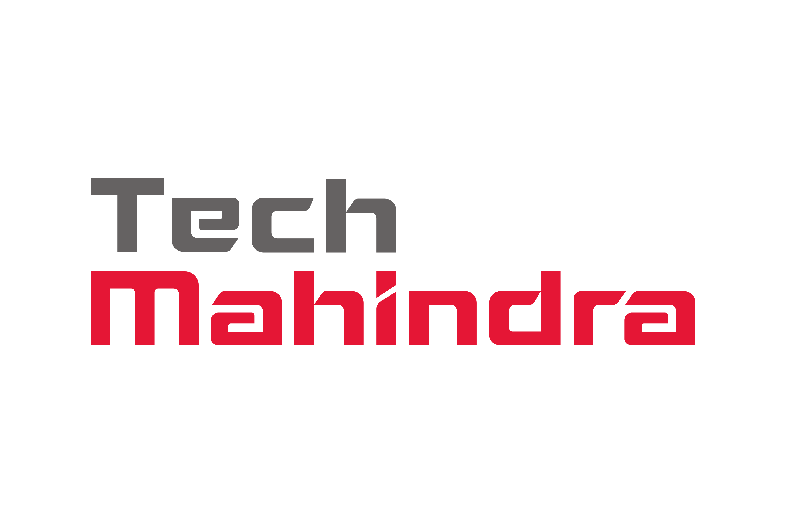

**BRITANNIA:**

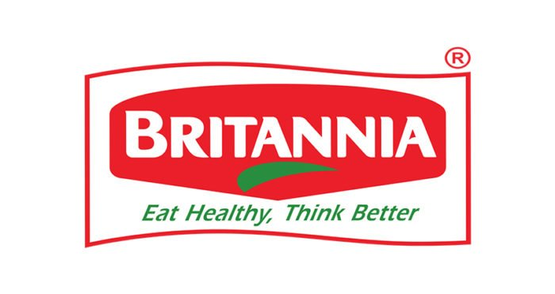

Britannia Industries Limited (BIL) is a multinational food products company that was founded in Kolkata in 1892. BIL is one of India's oldest companies and a leading FMCG company. The company's products include bakery items such as biscuits, breads, cakes, wafers, rusk, and croissants, and dairy products such as milk, cheese, butter, and yogurt. BIL's brand portfolio includes **Tiger, Marie Gold, Good Day, 50:50, Treat, NutriChoice, and Milk Bikis.**

**BACKGROUND**

**TECH MAHINDRA:**

Mahindra & Mahindra started a joint venture with British Telecom in 1986 as a technology outsourcing firm. Then the company was named Mahindra British Telecom (MBT). Later it was renamed as Tech Mahindra. British Telecom initially had around a 30 percent stake in Tech Mahindra. In December 2010, British Telecom sold 5.5 percent of its stake in Tech Mahindra to Mahindra & Mahindra for Rs. 451 crore. In August 2012, British Telecom sold 14.1 percent of its stake to institutional investors for about Rs. 1,395 crore. In December 2012, British Telecom sold its remaining 9.1 percent (11.6 million shares) shareholding to institutional investors for a total gross cash proceeds of Rs. 1,011.4 crores. This sale marked the exit of British Telecom from Tech Mahindra.

**BRITANNIA**

The company was established in 1892 by a group of British businessmen with an initial investment of ₹295.[10] Initially, biscuits were manufactured in a small house in central Kolkata. Later, the enterprise was acquired by the Gupta brothers, mainly Nalin Chandra Gupta, an attorney, and operated under the name, V.S. Brothers. In 1918, C.H. Holmes, an English businessman based in Kolkata, was taken on as a partner and The Britannia Biscuit Company Limited (BBCo) was launched. The Mumbai factory was set up in 1924 and Peek Freans acquired a controlling interest in BBCo. During World War II, the government of British India needed a continuous supply of biscuits for British soldiers. The Britannia Biscuit Company started supplying biscuits to the British Army for several years, and the company sometimes devoted 95% of its capacity to produce biscuits for the armed forces. Biscuits were in high demand during World War II, which gave a boost to the company's sales. The company name was changed to the current Britannia Industries Limited in 1979. In 1982, the American company Nabisco acquired the parent of Peek Freans and became a major foreign shareholder. In 1978, Britannia came out with its public issue, and its Indian shareholding had increased to 62%, which firmly established Britannia as an Indian company. The 38% foreign stake was owned by the UK-based Associated Biscuits International Limited (ABIL).

**Competitive advantage**

|  |  |  |
| --- | --- | --- |
| **BASIS** | **TECH MAHINDRA** | **BRITANNIA** |
| BRAND reputation | Tech Mahindra has a strong reputation in 2023, including being recognized as the only Indian IT company to make the Dow Jones Sustainability Indices for the ninth year in a row. It also received a double "A" rating for transparency on climate change and water security from CDP's 2023 questionnaires and was ranked number one in the S&P GlobalSustainability Yearbook 2023. | Britannia Industries is a food brand that has a strong reputation for its quality products and consistent taste. In 2022, Kantar India's Brand Footprint report ranked Britannia fourth in India's most chosen FMCG brands. The Economic Times also named Britannia's Good Day biscuit brand the Brand Equity's Most Trusted Brands of Indians in 2019-20. Britannia is also the market leader in Nepal.  as ranked 4th in the list of India's most chosen FMCG brands, as per Kantar India's annual Brand Footprint report. Britannia won the Global Sustainability Leadership Awards from the World Sustainability Congress in 2021. The Economic Times listed the company's Good Day biscuit brand as the Brand Equity's Most Trusted Brands of Indians in 2019-20. The company was selected for special recognition under the Leading RE Investor category at the Renewable Energy India Awards 2016. |
| Product differentiation | Under the “Mahindra” brand name, the company produces SUVs, Multi utility vehicles, pickups, lightweight commercial vehicles, heavyweight commercial vehicles, two wheeled motorcycles and tractors. | Britannia is a significant producer of biscuits as well as dairy items. The product mix of Britannia breadth focuses on biscuits, bread, dairy, cakes, and rusk. With their varied offerings, biscuits have the most extensive product range, followed by cakes and bread. |
| Technological innovation | IoT and Robotics To sense and make sense of the world around us. Blockchain Secure reality via distributed ledgers. Quantum Computing Our research extends from the physical to the quantum world, where we try and solve some of the unsolved. | Britannia Industries uses 9 technology products and services including jQuery , Google Analytics , and Google Fonts , according to G2 Stack. Britannia Industries is actively using 15 technologies for its website, according to BuiltWith. These include Viewport Meta , IPhone / Mobile Compatible , and Euro . |
| Market leadership | Mahindra Group's strategy of identifying businesses for future growth and focusing on capital allocation and scale is paying off, according to Chairman Anand G Mahindra. The company achieved its target ROE ahead of schedule. The group plans to invest Rs 10,000 crore into MEAL. | After a decade of being under the shadows of market leader Parle Products, Britannia has finally nosed ahead and is set to maintain its lead, ushering in changes in its marketing strategy. |
| Distribution netrwork | Tech Mahindra's Infrastructure & Cloud Services covers the entire Infrastructure stack and supports new age technologies that can help enterprises embrace a truly digital transformation | For distribution, Britannia follows the FMCG channel of distribution wherein it appoints distributors at select locations. These distributors are then responsible for handling dealers and retail showrooms. |

Analysing financial performance

**TECH MAHINDRA :**

* 1. **Revenue growth :**

According to Tech Mahindra 's latest financial reports the company's current revenue (TTM) is $6.39 B. In 2022 the company made a revenue of $6.47 B an increase over the years 2021 revenue that were of $5.70 B.

* 1. **Profit margin :**

According to Tech Mahindra 's latest financial reports and stock price the company's current Operating Margin is 11.79%. At the end of 2023 the company had an Operating Margin of 12.10%.

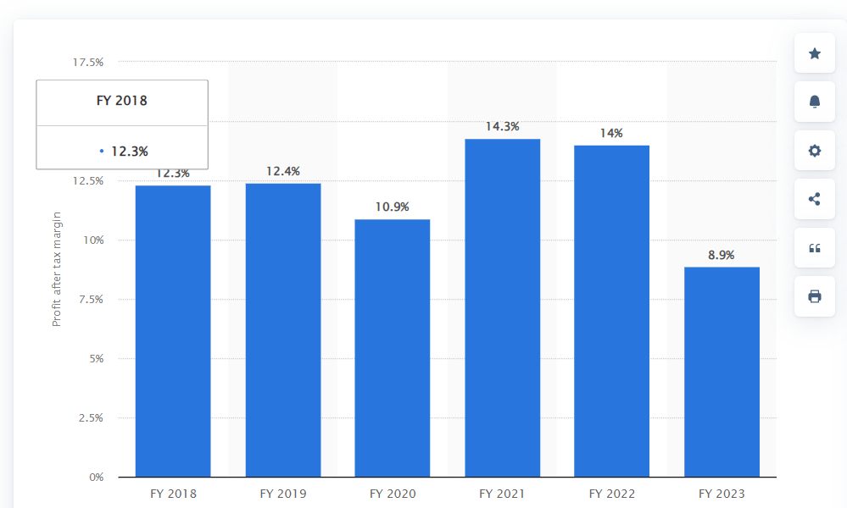

* 1. **Return on investment :**

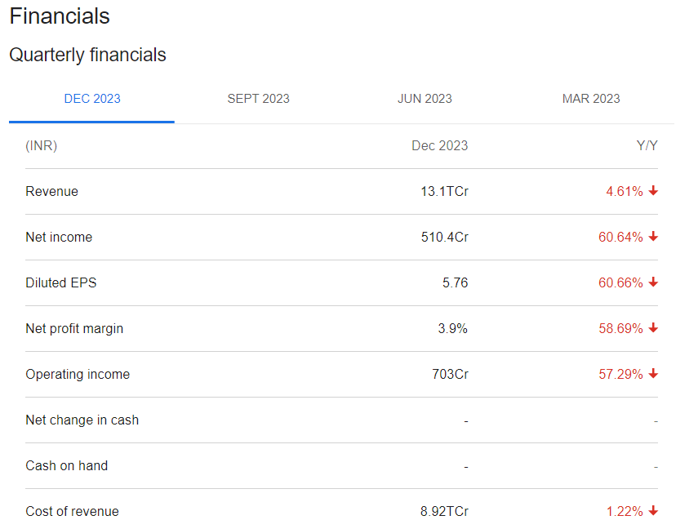

* 1. **Market share :**

Tech Mahindra share price as on 19 Mar 2024 is **Rs. 1281.55**. Over the past 6 months, the Tech Mahindra share price has increased by 0.13%.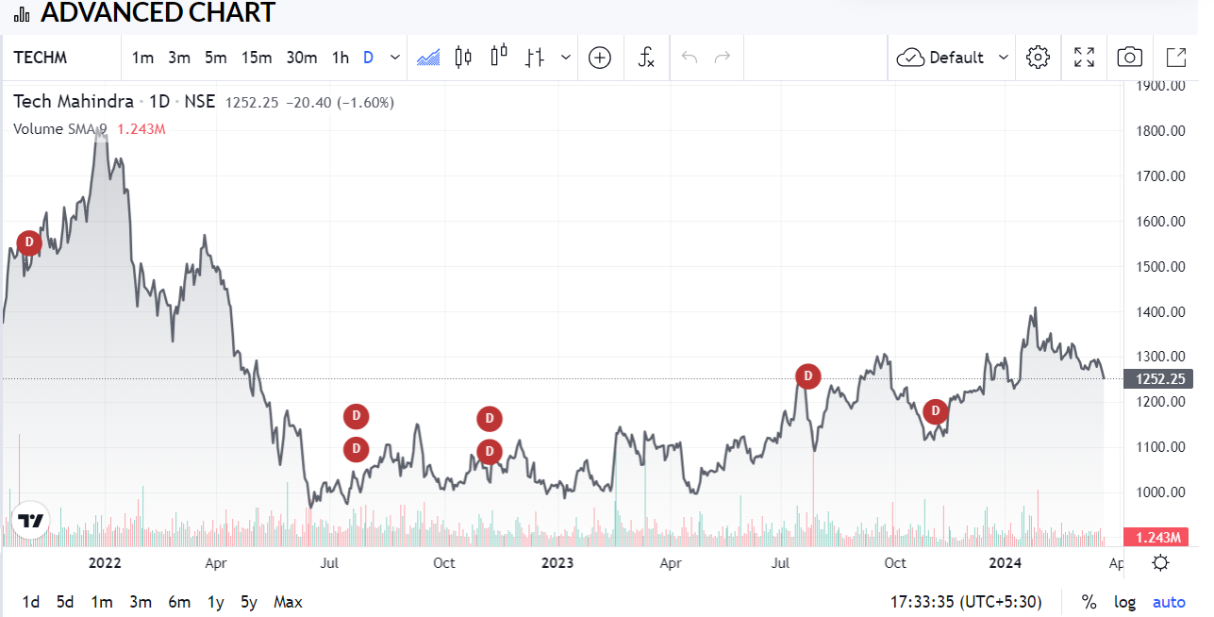

**BRITANIA :**

1. **Revenue growth :**

Axis Securities expects Britannia Industries to report 1-2% YoY revenue growth at ₹4,259 crore (1 digit volume growth) on back of anniversarization of price hikes and increase in competitive intensity. EBITDA margin is likely to remain flat at 19.5%.

1. **Profit margin :**

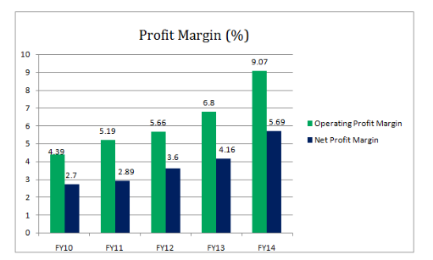

1. **Return on investment :**

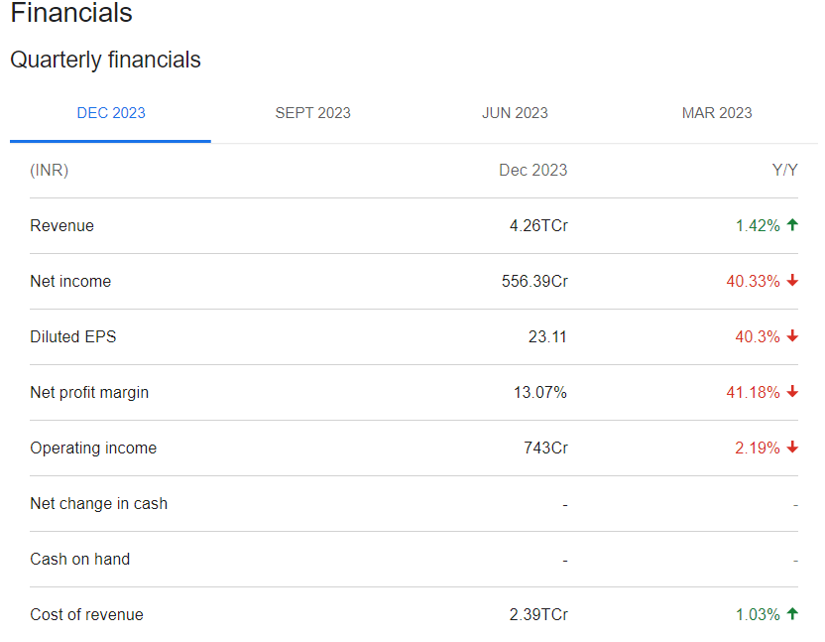

1. **Market Share :**

Biscuits. As of 2023, about 80% of Britannia's annual revenue comes from biscuits. Britannia has an estimated market share of 33% in the organised biscuits market in India. The company's factories have an annual capacity of 433,000 tonnes.

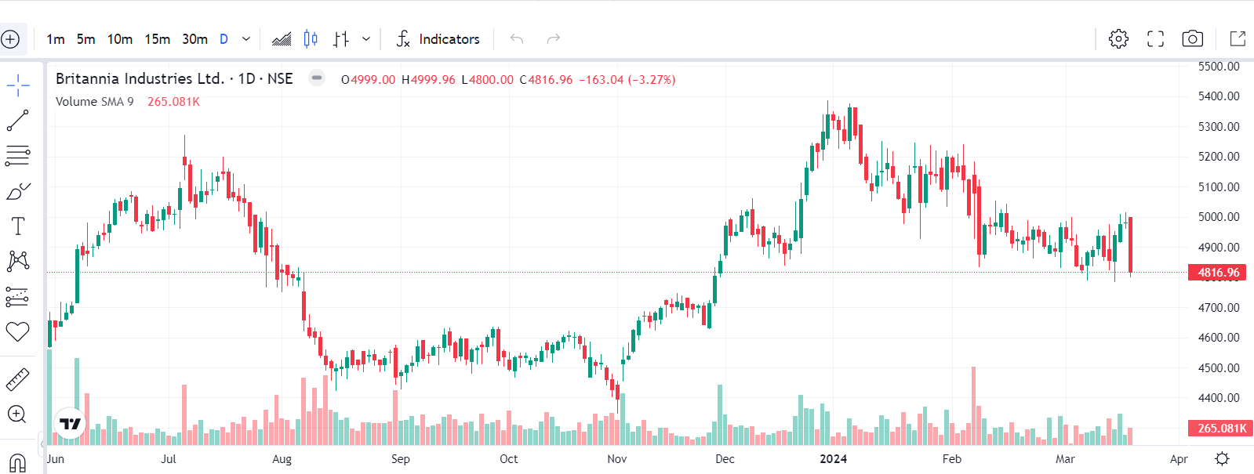

COMPARE COMPETITIVE POSITIONS

|  |  |  |
| --- | --- | --- |
| COMPANY NAME | TECH MAHINDRA | BRITANNIA |
| MARKET SHARE | Market Share: 11.4% | Britannia has an estimated market share of 33% in the organised biscuits market in India. |
| GROWTH PROSPECTS | Tech Mahindra is forecast to grow earnings and revenue by 32.6% and 6.4% per annum respectively. EPS is expected to grow by 32.5% per annum. Return on equity is forecast to be 31% in 3 years. | Britannia Industries is forecast to grow earnings and revenue by 10.5% and 9% per annum respectively. EPS is expected to grow by 10.5% per annum. Return on equity is forecast to be 53.7% in 3 years. |
| COMPETITIVE THREATS | Tech Mahindra competes with giants like Infosys, TCS, and Accenture, etc. Compared to its peers, Tech Mahindra has a lack of scale. INFY 2015, Tech Mahindra can only show 1/3 of the money earned by TCS. This puts Tech Mahindra in a dangerous position.  Most of Tech Mahindra’s revenues come from Europe and America, weak as the company is affected by any economic or political changes that take place in these markets. | Due to increasing numbers of brands ( local brands such as Anmol, Priya gold etc) the company is not able to differentiate its products from other brands. This can spoil the brand image of the company in the market. |
| BARRIERS TO ENTRY | When barriers are high, it is more difficult for new competitors to enter the market. High entry barriers positively affect profits for **Tech Mahindra**. | After facing initial GST hiccups, FMCG major Britannia is looking at increasing its distribution footprint and winning market share from local players.The company, which witnessed de-stocking in trade channels due to migration to GST, said the new tax regime has brought a level playing field. |

ASSESMENT OF SUSTAINABILITY

Sustainability assessment requires an evaluation of present and future conditions to show that present decisions and actions are not compromising future human and ecological health and well-being.

**TECH MAHINDRA :**

IT is about **making individual effort towards awareness and action on sustainability within and beyond Tech** Mahindra.

Ensure quality education through infrastructure development. Impacted 21,000 + lives till date with this program. Protecting and promoting community healthcare, safety and sanitation. To help protect our natural environment and combat climate change, we have planted 9 Lakh saplings over 15 years.

**BRITANNIA :**

From our analysis, and with the assumption that fundamentally the maritime sector (which includes our Members) is sustainable, we believe that the following SDGs are key to ensuring the future sustainability of Britannia P&I.

Conclusion

**TECH MAHINDRA :**

Tech Mahindra is a leading global technology company known for its innovative solutions and digital transformation expertise. With a commitment to excellence, it has consistently delivered cutting-edge services to clients worldwide. Mahindra & Mahindra has many firsts to its credit and is undoubtedly the manufacturing leader that has been following the highest quality standards and delivering all types of vehicles. The company has a global footprint with a presence in many countries.

**BRITANNIA :**

Britannia is well-known and has a large worldwide footprint. Britannia's SWOT analysis revealed that the organisation is trustworthy and has great brand recognition. But the primary issue is that it is facing rising market competition and has to improve its R&D department.

Britannia Industries is one of India's leading food com- panies with a 100 year legacy and annual revenues in excess of Rs. 9000 Cr.

**NAME: Paluri Naga sai ushasree**

**COLLEGE : DR. LANKAPALLI BULLAYA COLLEGE**